Light Box

Timber:
- Two lengths of pine 41cm x 14cm x 2cm (C, D)
- Two lengths of pine 45cm x 9.5cm x 2cm (A, B)
- One length of pine 1cm x 2cm x 2.5 metres to cut (E)
(The remainder is cut to produce inner rim on which to set the glass top. This can be taped in place, corners can be added or you can use double sided adhesive fixers).
- Light fitting: Most DIY places sell strip lights and you will need one to fit which allows room for plugs or cables. The sample in class used the shortest available but measure before you purchase to double check)
- Piece of Safety Glass to fit.
- Once timber for A, B, C, D is cut, pilot screw hole 1-8. Glue and screw to form box (make sure it is square in the corners 90 degrees or else glass will not fit).
- Cut 1cm x 2cm lengths as appropriate and panel pin and glue to produce inner rim, allow 4mm to fit in 3mm glass.
- Attach D with light fitting attached between centres of C and D at the lower end. Screw and glue to fix.
- After putting box together, measure the opening, take 2mm off each measurement and get your glass merchant to cut a piece of 3mm safety glass. Line this glass with tracing paper (stick down with masking tape) to create a diffused light and place in top of box.
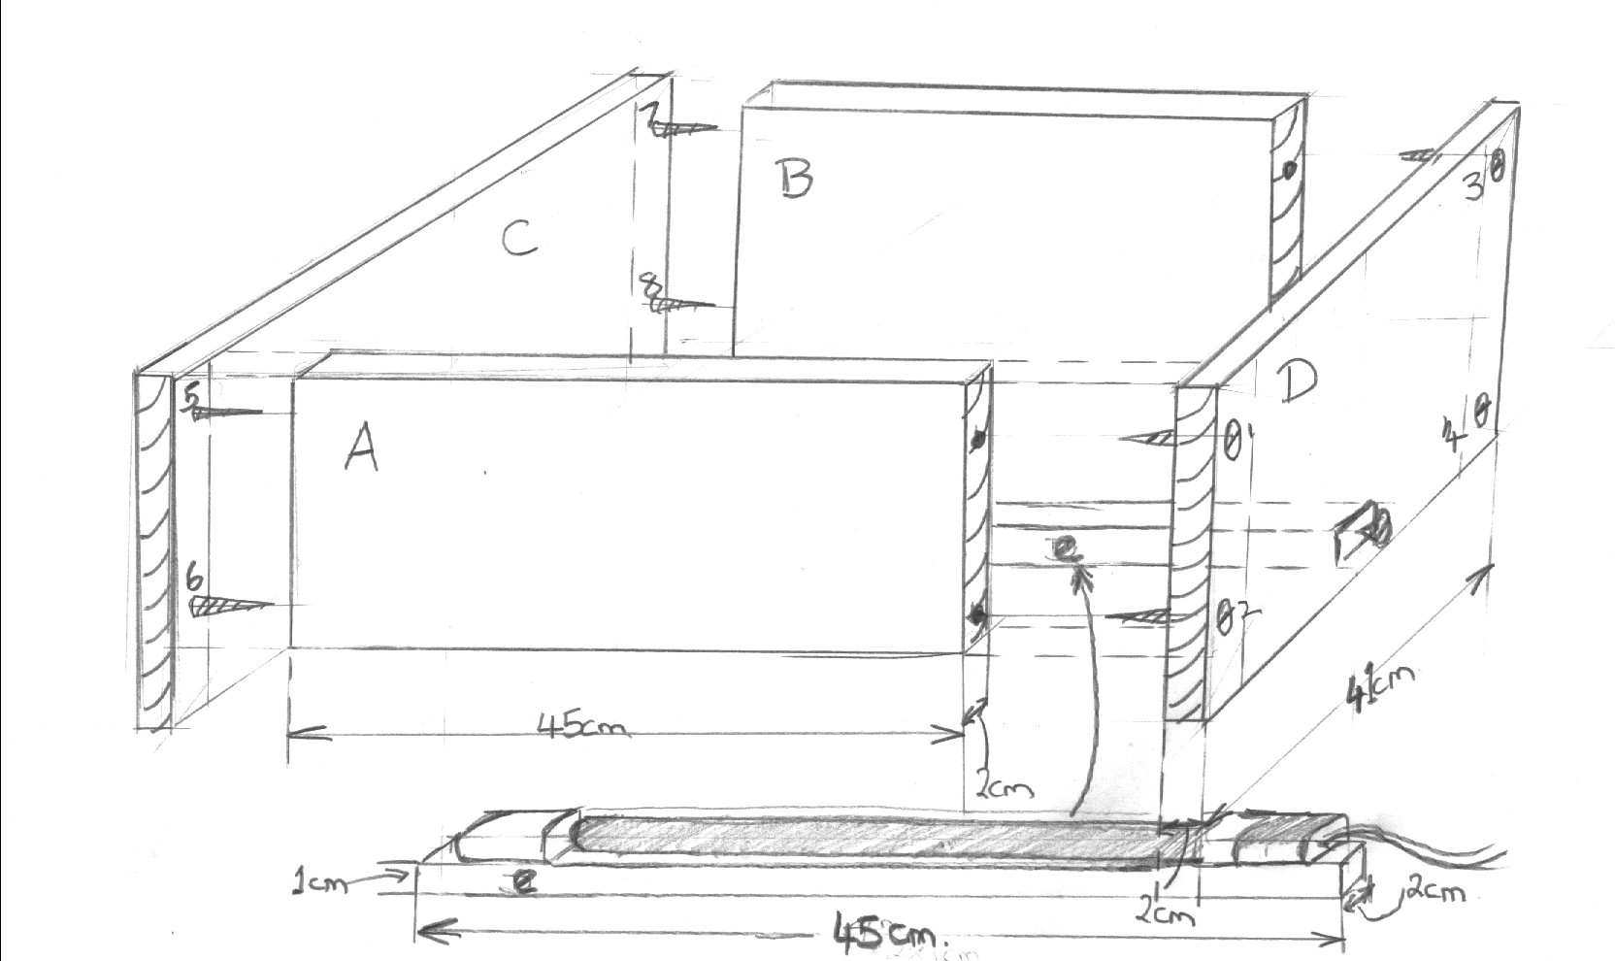Not to Scale

